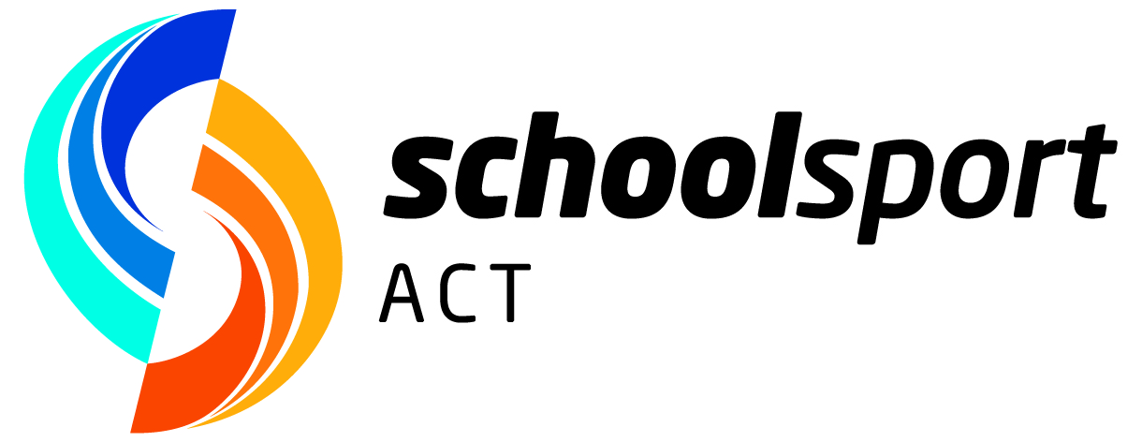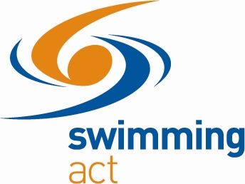

2024 Swimming: General Information
School Sport ACT gives all students access to their level of competition for swimming. Every school can have its own swimming carnival as an annual event. These cater for the serious swimmers as well as novelty and fun events to encourage participation by all students. These events are great to foster school spirit and a chance for the school community to come together as one.

School Sport Regional Carnivals and Swimming Selection Trials (including ASC)
Schools pick winners in each age group from their own carnival or swimmers who are competitive in time to compete at their Regional Swimming Carnival.

The Regional carnivals for primary students in 2024:

Region | Date | Pool | Entries close
Belconnen | Tuesday 26 March | AIS | Wednesday 20 March
Tuggeranong | Thursday 28 March | Stromlo | Friday 22 March
North/Gungahlin | Wednesday 3 April | AIS | Tuesday 26 March
South/Weston | Friday 5 April | Stromlo | Thursday 28 March

There are events in 50m in the 4 strokes for all age groups (8-13 years), as well as 100m events in all four strokes.
200m IM and 200m Freestyle – will not be conducted at Regional level. Up to four (4) competitors in each age group (10, 11, 12 years) will be entered from direct entries received to the ACT 12&U Swimming Championship – Entry Form must be submitted by the school no later than 12 April, found in Teacher Resources section of the website.

There are qualifying times that need to be met in order to proceed to the primary Regional Swimming Carnivals. These times will be sent to all schools and will be advertised on the School Sport ACT website. The 12 year olds qualifying time applies to 13 year old swimmers in primary school.

Regional Carnivals for Secondary students (12–16 years):

ASC: Wednesday 27 March at the AIS (Entries close Thursday 21 March)
Combined Regions: Tuesday 9 April at the AIS (Entries close Tuesday 2 April)
Note: Govt and Non Govt Colleges, schools with Year 11 and 12 students, which are not within the ASC, direct entries to the 13&O ACT Championship will need to be sent to school.liaison@swimmingact.com.au by 12th April.

200m IM and 200m Freestyle – will not be conducted at Regional level. Up to four (4) competitors in each age group will be entered from direct entries received to the ACT 13&O Swimming Championship – Entry Form must be submitted by the school no later than 27 April, found in Teacher Resources section of the website.

Entry cut off date
There will be a cut off date for entries for the Regional Carnivals to be received by School Sport ACT and Lorraine Wuth, Swimming ACT Liaison. These dates will be strictly adhered to, and late entries will not be processed, this is to facilitate the smooth transfer of data and the efficient running of all carnivals.

Multi Class Swimmers
Students with a disability, para-athletes, may choose to swim as an able bodied student at the Regional carnivals, as long as they meet the qualifying standards and qualify through their school carnival. If these students wish to be considered for selection to go to the National Championships, they need to swim at the ACT Swimming Championship as a Multi Class swimmer. These students will need to fill out a nomination form for the ACT event. This form will be available through the School Sport ACT website and also distributed to all schools. Multi Class swimmers who swim at any carnival need to provide an assistant to help them if they require it.

School Sport ACT State Swimming Championships
The SSACT ACT Swimming Championships will take place at the AIS on:
- Tuesday 7 May – 12 Years & Under – including students turning 12 in Year 7.
- Thursday 9 May – 13 Years & Over – including students turning 13 in Year 6.
(Govt and Non Govt (not ASC) College entries close Friday 12 April)

The place getters in each age group from the Regional Carnivals go on to represent their School/Region at the School Sport ACT Swimming Championships at the AIS Pool on Tuesday 7 and Thursday 9 May 2024 (qualifying times must be met). Events for 8-12 years are the same as Regional Carnivals, except with the addition of the 200IM and 200 Freestyle. For 13-19 years, the program includes 50m and 100m in the 4 strokes, 200m IM and the 200m Freestyle.

Schools will be notified as to which of their students are proceeding to the Championships.

Request for Inclusion
Request for Inclusion Applications for Regional events must be submitted before the specified Entry Closing date and for ACT Championships applications must be submitted by Friday 12 April for the 12&U ACT Championships and Tuesday 30 April for 13&O ACT Championships.

School Sport Australia Swimming Championships
The School Sport ACT Swimming Championships are the selection meets to form our SSACT State Swimming Team for the School Sport Australia Swimming Championships – 10 to 12 Years, 24-27 July and 13 to 19 Years, 27 – 31 July, Gold Coast, Queensland.

Note: If a student does not compete at their respective ACT Championship they are not eligible for State Team selection.

Students are invited to register their expression of interest in State Team selection prior to the ACT Championship, via the Swimming page on the SSACT website, the portal for registrations will be open in the week prior to the Championship.

Further details will be posted on the School Sport ACT website as they become available.

