Website Guide for students selected into ACT Teams

Uniform Selection and Payment
PLEASE NOTE: Uniform must be selected PRIOR to paying the deposit (if the deposit is paid first, this will result in the student’s profile being locked)
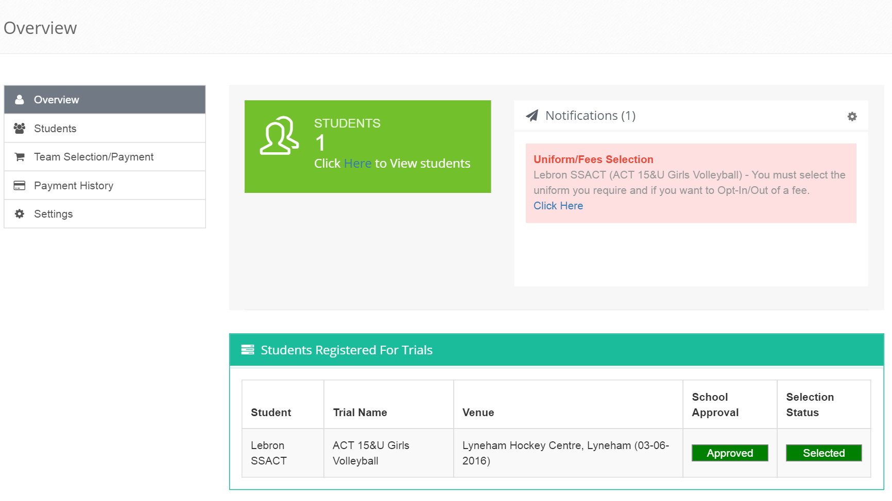
- Click on Uniform/Fees Selection
- Click on Select Uniform
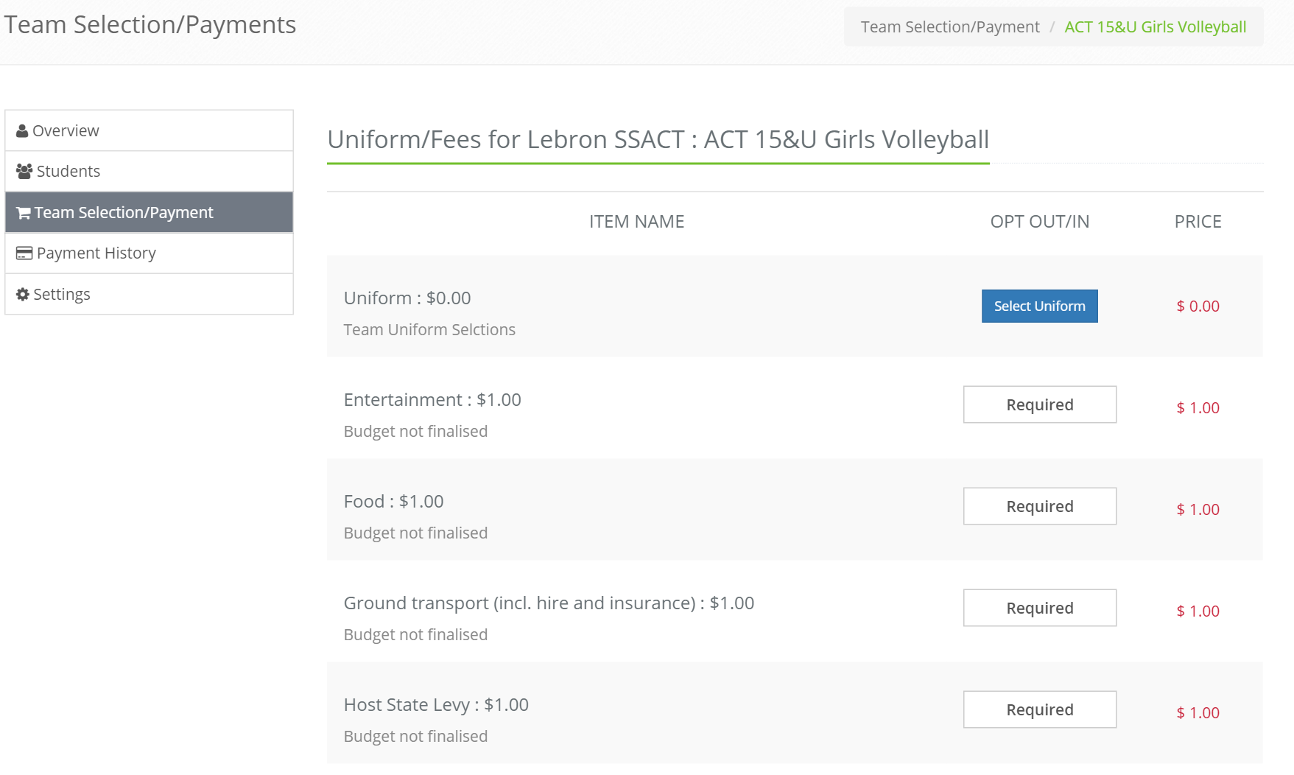
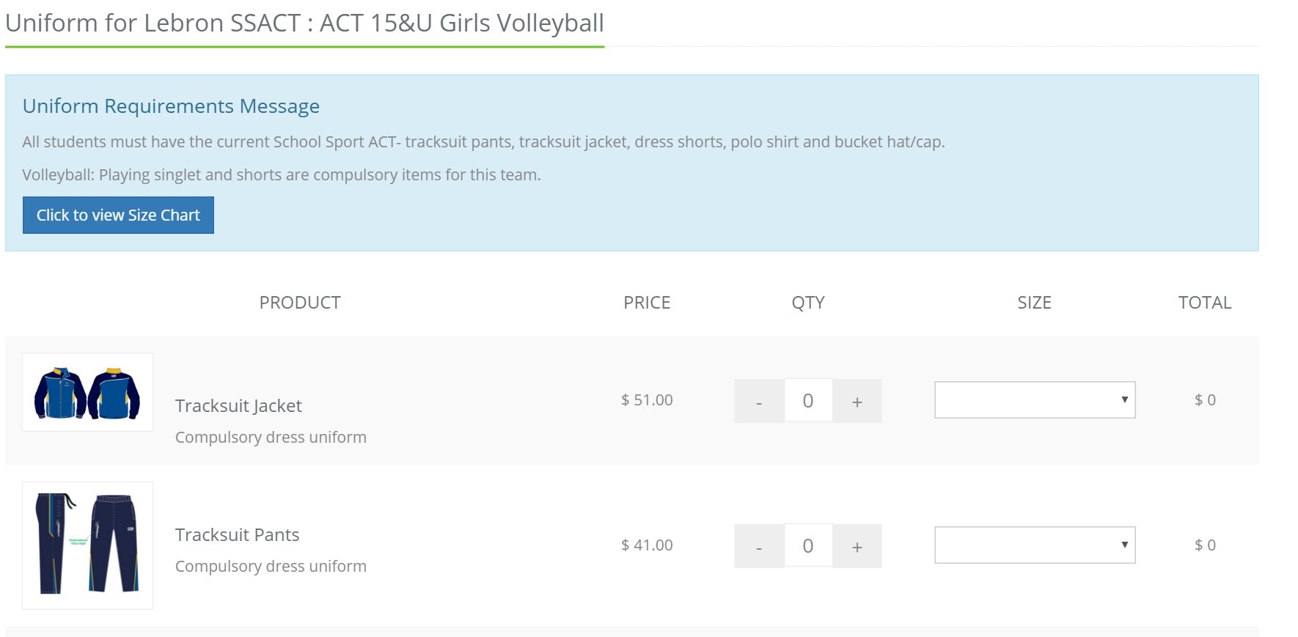
- Click on Quantity and Size to make selections for each item

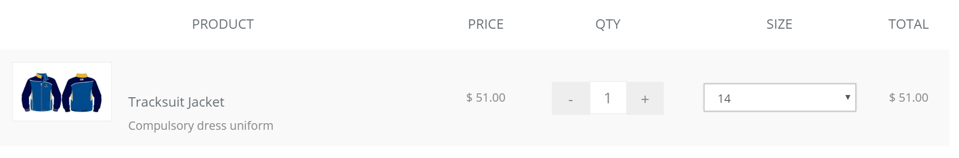
PLEASE NOTE: If you would like more than one of an item, but in different sizes, you will need to select to correct quantity and then email School Sport ACT at info@schoolsportact.org.au with the size choice (unfortunately the website does not allow various sizes of the same item to be selected).
- Once you have selected the uniform click on Save Uniform Selection at the bottom of the page
- This will then bring you to this screen, where you will need to click on Confirm Selection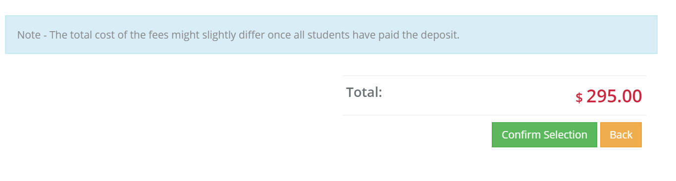
PLEASE NOTE: Once you have confirmed selection the uniform is not editable and you will need to contact School Sport ACT to make any changes.

- Once you have confirmed selection – click on Proceed to Payment Page to pay the deposit
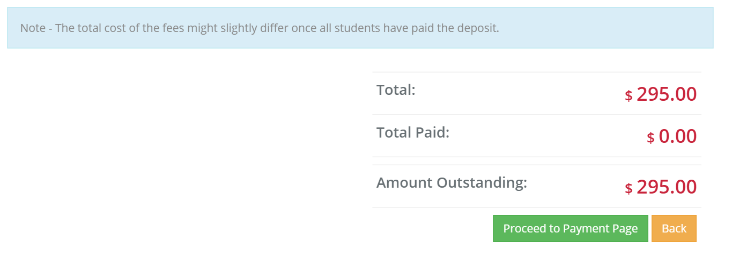

This will now take you to the page where you will pay the $200 deposit ONLY
- Enter the appropriate details and click on Make Payment
For other payment options, click on Click to view other payment options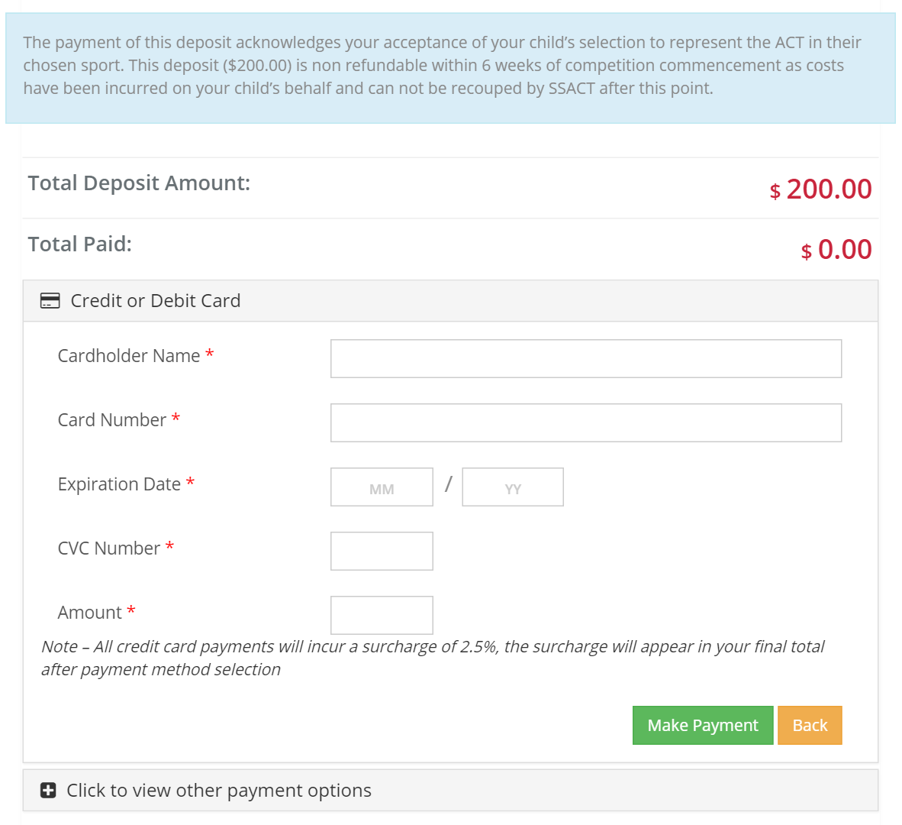

Once the full budget has been finalised by the team’s officials, they will let you know and you will be able to make further payments (see below for how to do this). The deposit is non-refundable within 6weeks of the championship.

- On the Overview page, click on Team Selection/Payment
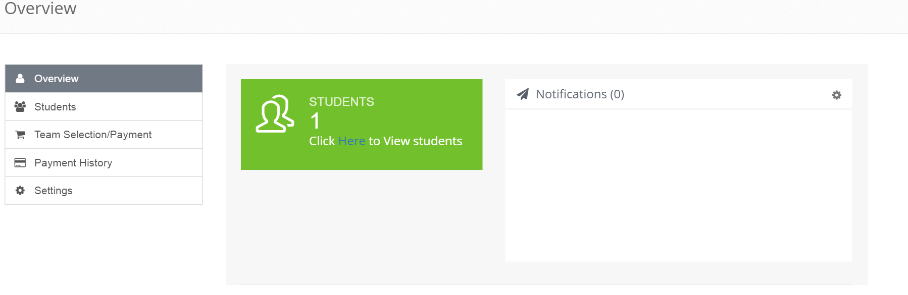
- Click on Edit
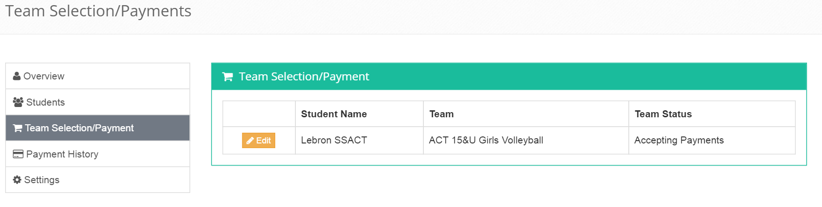

- Repeat steps 6 and 7

PLEASE NOTE: You will not receive your uniform until payment has been made in full. If payment is made after the uniform has been distributed, you will need to collect it from the School Sport ACT office.

HOW TO MAKE FINAL PAYMENTS

First you will need to log in to your School Sport ACT profile.
From there, select “Team Payments/ Selection on the left hand side.

Then “edit” next to the name of the child you wish to make payment for.

From there it will take you to a payment page which shows the list of budgeted items. Scroll down to the bottom where you can go through to the different options of payment that are available.

