- Parents to go to My Profile, click Payments and Uniform;

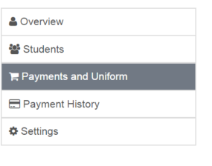
- Open specific Student, scroll to the bottom Uniform/Fees for ………and Click on Proceed to Payment Page

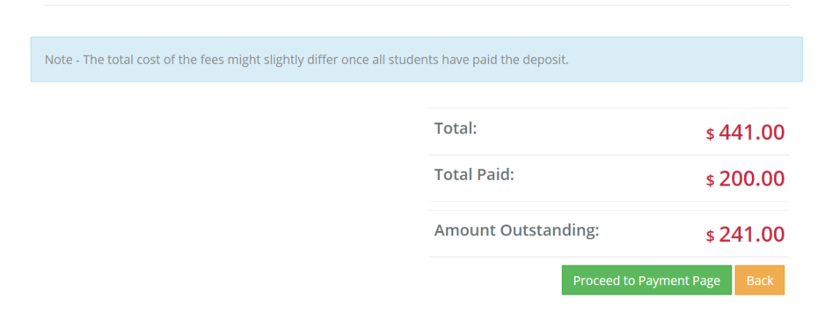

- Make payment via Credit Card with desired amount or select Click View other payment options for Direct Deposit and Cash
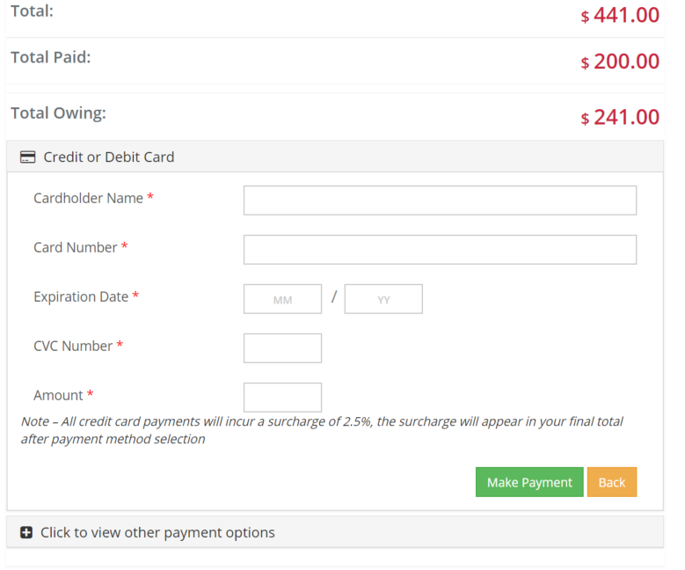
Note that Direct Deposits not seen for 2 -3 days and need to be manually removed from total, thus the importance of paying in full at least 7 – 10 days prior to departure.

